

**VISHAW BANSAL**

**1024030356**

**ASSIGNMENT** 1

**Answer 1**

**#include <iostream>**

**#include <math.h>**

**#include <iostream>**

**using namespace std;**

**const int MAX_SIZE = 100;**

**int main() {**

**int arr[MAX_SIZE];**

**int size = 0;**

**int choice, element, position, searchElement, foundIndex;**

**bool found;**

**do {**

**cout << "\n===== ARRAY OPERATIONS MENU =====\n";**

**cout << "1. CREATE Array\n";**

**cout << "2. DISPLAY Array\n";**

**cout << "3. INSERT Element\n";**

**cout << "4. DELETE Element\n";**

**cout << "5. LINEAR SEARCH\n";**

**cout << "6. EXIT\n";**

**cout << "Enter your choice (1-6): ";**

**cin >> choice;**

**switch(choice) {**

**case 1:**

**cout << "Enter the size of array (max " << MAX_SIZE << "): ";**

**cin >> size;**

**if(size <= 0 || size > MAX_SIZE) {**

**cout << "Invalid size! Size should be between 1 and " << MAX_SIZE << endl;**

**size = 0;**

**break;**

**}**

**cout << "Enter " << size << " elements:\n";**

**for(int i = 0; i < size; i++) {**

**cin >> arr[i];**

**}**

**cout << "Array created successfully!\n";**

**break;**

**case 2:**

**if(size == 0) {**

**cout << "Array is empty! Please create array first.\n";**

**break;**

**}**

**cout << "Array elements: [";**

**for(int i = 0; i < size; i++) {**

**cout << arr[i];**

**if(i != size-1) cout << ", ";**

**}**

**cout << "]\n";**

**break;**

**case 3:**

**if(size >= MAX_SIZE) {**

**cout << "Array is full! Cannot insert more elements.\n";**

**break;**

**}**

**cout << "Enter the element to insert: ";**

**cin >> element;**

**cout << "Enter the position (0 to " << size << "): ";**

**cin >> position;**

**if(position < 0 || position > size) {**

**cout << "Invalid position!\n";**

**break;**

**}**

**for(int i = size; i > position; i--) {**

**arr[i] = arr[i-1];**

**}**

**arr[position] = element;**

**size++;**

**cout << "Element inserted successfully!\n";**

**break;**

**case 4:**

**if(size == 0) {**

**cout << "Array is empty! Nothing to delete.\n";**

**break;**

**}**

**cout << "Enter the position to delete (0 to " << size-1 << "): ";**

**cin >> position;**

**if(position < 0 || position >= size) {**

**cout << "Invalid position!\n";**

**break;**

**}**

**cout << "Deleted element: " << arr[position] << endl;**

**for(int i = position; i < size-1; i++) {**

**arr[i] = arr[i+1];**

**}**

**size--;**

**cout << "Element deleted successfully!\n";**

**break;**

**case 5:**

**if(size == 0) {**

**cout << "Array is empty! Nothing to search.\n";**

**break;**

**}**

**cout << "Enter the element to search: ";**

**cin >> searchElement;**

**found = false;**

**for(int i = 0; i < size; i++) {**

**if(arr[i] == searchElement) {**

**foundIndex = i;**

**found = true;**

**break;**

**}**

**}**

**if(found) {**

**cout << "Element found at position: " << foundIndex << endl;**

**} else {**

**cout << "Element not found in the array.\n";**

**}**

**break;**

**case 6:**

**cout << "Exiting program...\n";**

**break;**

**default:**

**cout << "Invalid choice! Please enter a number between 1 and 6.\n";**

**}**

**} while(choice != 6);**

**return 0;**

**}**

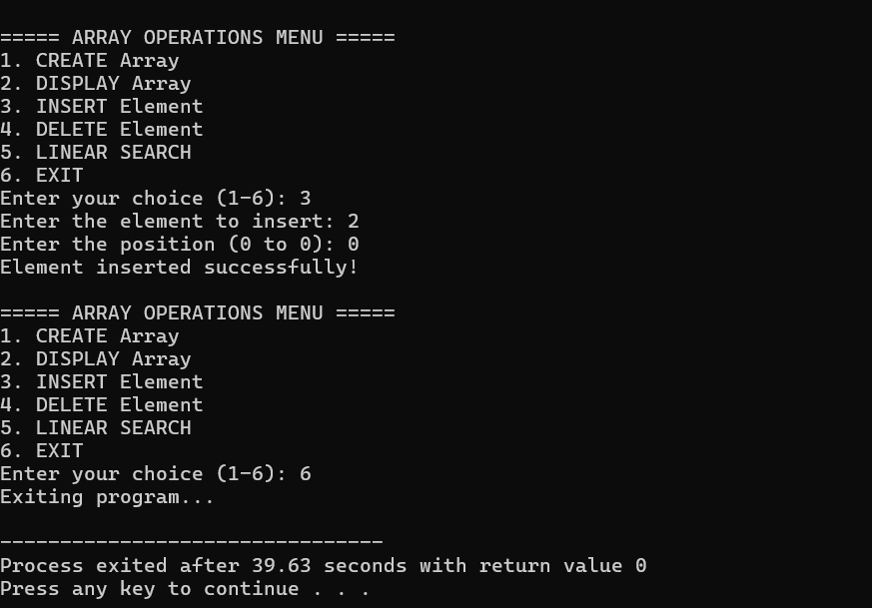

**Answer 2**

#include <iostream>

using namespace std;

int main()

{

int arr[100], size, i, j, k;

cout << "Enter the number of elements: ";

cin >> size;

cout << "Enter " << size << " elements:" << endl;

for (i = 0; i < size; i++) {

cin >> arr[i];

}

for (i = 0; i < size; i++) {

for (j = i + 1; j < size;) {

if (arr[i] == arr[j]) {

for (k = j; k < size - 1; k++) {

arr[k] = arr[k + 1];

}

size--;

} else {

j++;

}

}

}

cout << "Array after removing duplicates:" << endl;

for (i = 0; i < size; i++) {

cout << arr[i] << " ";

}

return 0;

}

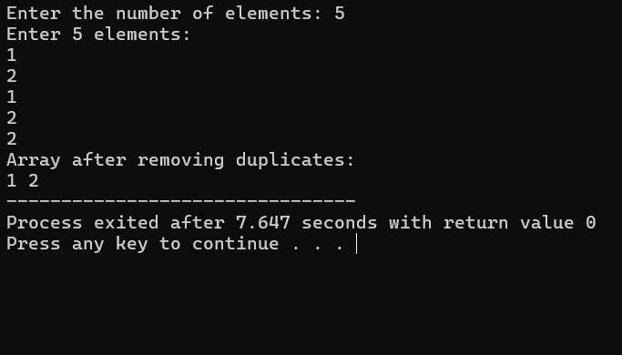

**Answer 3**

the output is  1 0 0 0 0

**Answer 4 ……**

**Answer 5**

**#include <iostream>**

**using namespace std;**

**int main() {**

**int rows, cols;**

**cout << "Enter the number of rows: ";**

**cin >> rows;**

**cout << "Enter the number of columns: ";**

**cin >> cols;**

**int matrix[rows][cols];**

**cout << "Enter the elements of the matrix:\n";**

**for (int i = 0; i < rows; i++) {**

**for (int j = 0; j < cols; j++) {**

**cin >> matrix[i][j];**

**}**

**}**

**cout << "\nRow sums:\n";**

**for (int i = 0; i < rows; i++) {**

**int rowSum = 0;**

**for (int j = 0; j < cols; j++) {**

**rowSum += matrix[i][j];**

**}**

**cout << "Sum of row " << i + 1 << ": " << rowSum << endl;**

**}**

**cout << "\nColumn sums:\n";**

**for (int j = 0; j < cols; j++) {**

**int colSum = 0;**

**for (int i = 0; i < rows; i++) {**

**colSum += matrix[i][j];**

**}**

**cout << "Sum of column " << j + 1 << ": " << colSum << endl;**

**}**

**return 0;**

**}**

